**Aim:**

To demonstrate Platform as a Service (PaaS) by creating a simple web application using Python or Java and hosting it on Azure App Service, without managing the underlying Virtual Machines or infrastructure.

**Procedure:**

1. Develop a Simple Web Application

* Create a Python (Flask) or Java (Spring Boot) web application on your local machine.

2. Push Code to GitHub

* Create a new GitHub repository.
* Initialize Git in your project folder, commit your code, and push it to GitHub.

3. Create an Azure Web App

* Login to Azure Portal.
* Navigate to App Services → + Create → Web App.
* Configure Basics:
  + Resource Group: PaaS-Demo-RG
  + Web App Name: Unique name (e.g., paas-demo-webapp123)
  + Runtime Stack: Python 3.10 or Java 11
  + Operating System: Linux or Windows
  + Region: Central India
* App Service Plan: Free (F1)
* Click Review + Create → Create

4. Connect GitHub Repository for Deployment

* Go to Deployment Center → GitHub.
* Authenticate GitHub, select your repository and branch (main).
* Save → Azure automatically deploys your application.

5. Verify Deployment

* Open the Default URL of the Web App in a browser.
* Confirm that the web application is running correctly.

**OUTPUT:**

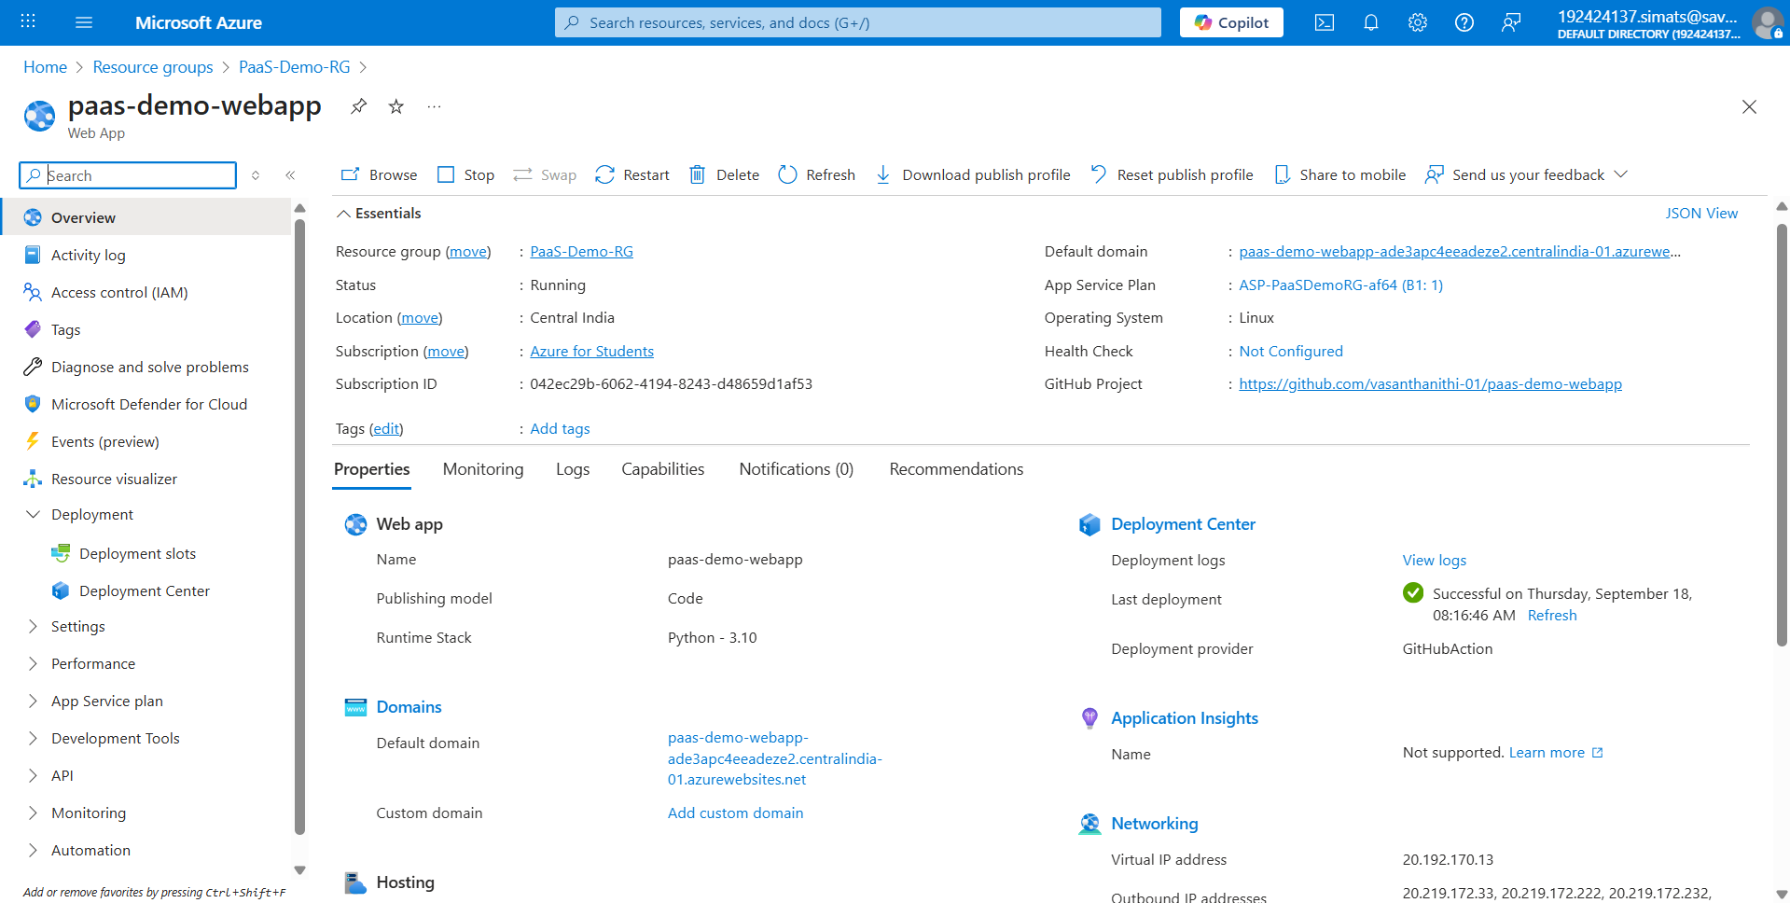

**Result:**

The web application was successfully hosted on Azure App Service. The application ran without provisioning or managing any Virtual Machines, demonstrating the PaaS model, where Azure handles the infrastructure, runtime, and scaling automatically.